Assignmnet-10
MINI PROJECT REPORT
on
AIR QUALITY ANALYSIS AND PREDICTION USING DATA MINING TECHNIQUES
Subject: Data Warehousing and Mining
Submitted by
Name -Anushka Chaturvedi
Roll No: 10
Class: CE-1 Batch-A
PRN-2414110192

Abstract
Air pollution is one of the most serious environmental and public-health problems in India. Many cities record dangerous concentrations of fine particulate matter and gaseous pollutants, especially during the winter months. Large volumes of monitoring data are collected every day, but raw readings are difficult to interpret without systematic analysis.
This mini project applies the core data mining techniques studied in the course to the publicly available dataset "Air Quality Data in India (2015-2020)", which contains daily pollutant readings and the Air Quality Index (AQI) for 26 Indian cities. The work covers the complete data mining workflow: preprocessing of missing values and outliers, linear regression (with a Random Forest benchmark) to predict the AQI value, classification of the AQI category using a decision tree (the Python counterpart of the J48 algorithm) and Naive Bayes (again with a Random Forest benchmark), K-Means clustering to group cities with similar pollution profiles, and Apriori association rule mining to discover combinations of pollutant levels that lead to poor air quality.
All techniques are combined in an interactive web application built with Python and Streamlit, which allows a user to explore the data, view model performance, tune parameters and predict the AQI and its category for any set of pollutant values. The project demonstrates how multiple data mining methods complement each other: regression quantifies the influence of each pollutant, classification predicts the health category, clustering groups similar cities, and association rules express patterns in a readable if-then form. On the test data the Random Forest benchmark reached an R-squared of 0.91 for regression and 80.7% accuracy for classification, compared with an R-squared of 0.83 for linear regression and accuracies of 75.2% (decision tree) and 67.3% (Naive Bayes).

1. Introduction

1.1 Background
Air quality has a direct effect on human health, agriculture and climate. Exposure to fine particles (PM2.5) and gases such as nitrogen dioxide and sulphur dioxide is linked to asthma, heart disease and reduced life expectancy. In India, the Central Pollution Control Board (CPCB) operates a network of monitoring stations that record pollutant concentrations and compute the National Air Quality Index (AQI), a single number that summarises how clean or polluted the air is.
The volume of data produced by this network is large and grows every day. Data mining provides a set of techniques for turning such data into knowledge: finding which factors matter, predicting future values, grouping similar entities and uncovering hidden patterns.

1.2 Problem Statement
To analyse daily air quality data of Indian cities using data mining techniques in order to (a) clean and prepare the data, (b) predict the AQI value and its category from pollutant concentrations, (c) group cities with similar pollution behaviour, (d) discover association patterns between pollutant levels and air quality, and (e) present the results through a simple interactive application.

1.3 Objectives
- To apply preprocessing techniques (duplicate removal, missing value imputation and outlier handling) to a large real-world dataset.
- To build a regression model that predicts the numeric AQI and identifies the most influential pollutants.
- To classify days into AQI categories using a decision tree (J48 equivalent) and Naive Bayes, and compare their performance.
- To cluster cities using K-Means and interpret each cluster.
- To mine association rules relating pollutant levels to AQI categories using the Apriori algorithm.
- To integrate all the above in a user-friendly Streamlit application.

1.4 Scope
The project is limited to daily city-level data for 26 Indian cities from 2015 to mid-2020. It uses eight major pollutants as input features. The application is intended for academic demonstration and is not a certified forecasting system.

2. Dataset Description

2.1 Source
The dataset used is Air Quality Data in India (2015 - 2020), published on Kaggle and compiled from CPCB records (https://www.kaggle.com/datasets/rohanrao/air-quality-data-in-india). The download contains five files: city_day, city_hour, station_day, station_hour and stations. This project uses city_day.csv, which holds daily readings per city and contains approximately 29,500 records and 16 attributes. The hourly and station-level files are much larger and were not required for the objectives of this project.

2.2 Attributes
Each record represents one city on one day. The attributes are described in
Table 2.1.
Attribute | Description | Type
City | Name of the city where the readings were taken | Categorical
Date | Date of the reading (2015 to 2020) | Date
PM2.5, PM10 | Particulate matter below 2.5 and 10 micrometres (ug/m3) | Numeric
NO, NO2, NOx | Nitric oxide, nitrogen dioxide and total nitrogen oxides (ug/m3) | Numeric
NH3 | Ammonia (ug/m3) | Numeric
CO | Carbon monoxide (mg/m3) | Numeric
SO2 | Sulphur dioxide (ug/m3) | Numeric
O3 | Ground-level ozone (ug/m3) | Numeric
Benzene, Toluene, Xylene | Volatile organic compounds (ug/m3) | Numeric
AQI | Air Quality Index calculated by CPCB | Numeric (target for regression)
AQI_Bucket | Category of air quality derived from the AQI | Categorical (target for classification)
Table 2.1: Attributes of city_day.csv

2.3 AQI Categories
The National AQI of India divides the index into six categories, each linked to a health impact (Table 2.2). The AQI_Bucket attribute follows this scale.
AQI Range | Category | Likely Health Impact
0 - 50 | Good | Minimal impact
51 - 100 | Satisfactory | Minor breathing discomfort to sensitive people
101 - 200 | Moderate | Breathing discomfort to people with lung or heart disease
201 - 300 | Poor | Discomfort on prolonged exposure
301 - 400 | Very Poor | Respiratory illness on prolonged exposure
401 - 500 | Severe | Affects healthy people and seriously affects those with existing diseases

3. Tools and Technologies
The project is implemented entirely in Python. The libraries used and their roles are listed in Table 3.1.
Tool / Library | Purpose
Python 3 | Programming language for the whole project
Pandas | Loading, cleaning and transforming the dataset
Scikit-learn | Linear regression, decision tree, Naive Bayes, K-Means, scaling and evaluation metrics
MLxtend | Apriori algorithm and association rule generation
Streamlit | Interactive web interface with tabs, sliders and charts
VS Code | Development environment
Table 3.1: Tools and libraries
Weka offers the J48 algorithm directly. Since scikit-learn does not include J48, a decision tree is used, with the split criterion (entropy or gini) chosen by grid search; the search selected the entropy criterion. J48 is the Weka implementation of C4.5, which also selects splits using information-based measures, so the two are conceptually equivalent.

4. System Design and Methodology
The project follows the standard knowledge discovery process. The data flows through the stages below, and the output of every stage is shown in a separate tab of the application.
- Data collection: city_day.csv is loaded into a Pandas DataFrame.
- Preprocessing: duplicates are removed, rows without a target are dropped, missing pollutant values are imputed and extreme outliers are capped (for the supervised models the cap is learned from the training data only).
- Model building: the cleaned data is split into 80% training and 20% testing sets (stratified by AQI category, random state 42 for reproducibility). Regression and all classifiers are trained on the same split so that results are comparable. A Random Forest is included as a non-linear benchmark for both tasks. The application also offers a chronological split (train on the earliest 80% of days, test on the latest 20%) as a stricter check; all results in this report use the random split unless stated otherwise.
- Unsupervised analysis: K-Means is applied to city-level averages (outliers capped at the 99th percentile) and Apriori is applied to discretised data.
- Evaluation: R-squared, mean absolute error and RMSE for regression; accuracy, precision, recall, F1-score, confusion matrix and permutation feature importance for classification; elbow curve and silhouette score for clustering; and support, confidence and lift for rules.
- Deployment: all outputs and a prediction form are presented through Streamlit.
Eight pollutants (PM2.5, PM10, NO, NO2, NH3, CO, SO2 and O3) are used as input features. NOx was excluded because it is derived from NO and NO2, and Benzene, Toluene and Xylene were excluded because they have a very large share of missing values in most cities.

5. Data Preprocessing
Real sensor data contains gaps, duplicates and abnormal values, so models trained directly on raw data give unreliable results. Preprocessing is therefore the first and one of the most important steps.

5.1 Removing Duplicates and Missing Targets
Duplicate rows are removed. Records where AQI or AQI_Bucket is missing are dropped, because the supervised techniques need a known target and imputing the target would introduce artificial values. The Date column is converted to a datetime type so that monthly trends can be computed.

5.2 Handling Missing Pollutant Values
Several pollutants have many missing values because monitoring equipment is not available at all times. Instead of one global average, each missing value is replaced with the median of the same city. The median is used because pollutant data is right-skewed and the mean is pulled upwards by pollution spikes. A city-wise value is more realistic since typical pollution levels differ greatly between cities, for example between a northern industrial city and a coastal city. If a city has no reading for a pollutant at all, the overall median is used as a fallback.

5.3 Outlier Treatment
Pollutant concentrations contain a few extreme readings, which may be sensor errors or genuine extreme events. To prevent them from dominating the regression line and the cluster centres, pollutant values are capped at their 99th percentile. For the supervised models that are sensitive to outliers (Linear Regression and Naive Bayes) the cap is learned from the training set only and applied inside the model pipeline, so that no information from the test set leaks into training; for clustering, the readings are capped before the city averages are computed. Tree-based models are not affected by extreme values and use the original readings. This keeps all rows in the dataset while limiting the influence of extreme values.

5.4 Results of Preprocessing
The number of rows before cleaning was 29,531 and after cleaning 24,850. No duplicate rows were found; the 4,681 rows that were removed are those without an AQI value. The dataset covers 26 cities from January 2015 to July 2020. The pollutants with the highest share of missing values before cleaning were Xylene (about 61%), PM10 (about 38%) and NH3 (about 35%), followed by Toluene (about 27%). After cleaning, none of the eight feature columns contains missing values.
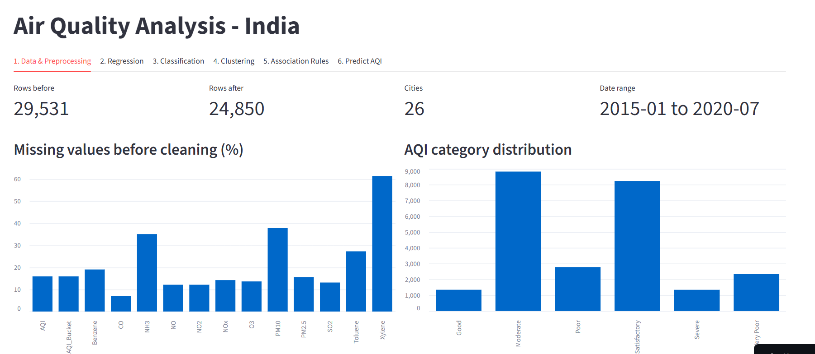

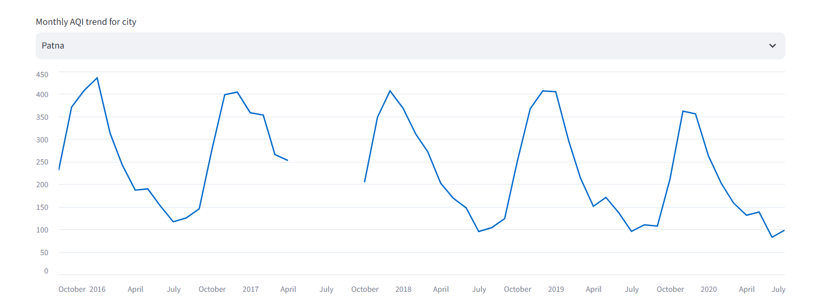

The monthly trend chart shows seasonality in pollution. In many northern cities AQI rises in the winter months, which is commonly attributed to lower wind speed, temperature inversion, crop residue burning and festival emissions. The monthly trend of Patna illustrates this: the AQI climbs to roughly 400 every winter (October to January) and falls to about 100 in July and August, in each of the five years. The category chart also shows that the classes are imbalanced: Moderate (8,829 days) and Satisfactory (8,224 days) are far more frequent than Good (1,341 days) and Severe (1,338 days), which is why F1-scores and per-class results are reported in addition to accuracy.

6. Regression Analysis

6.1 Concept
Regression predicts a continuous numeric value. In this project, multiple linear regression models the AQI as a weighted sum of the pollutant concentrations: AQI = b0 + b1(PM2.5) + b2(PM10) + ... + b8(O3). The coefficients show how many AQI points change for a unit change in a pollutant while the others are held constant.

6.2 Implementation
The cleaned data is split 80:20. A LinearRegression model from scikit-learn is fitted on the training set (outliers are capped and the inputs standardised inside the pipeline, so that the coefficients are comparable), and a Random Forest regressor with 200 trees is trained as a non-linear benchmark. Both models are evaluated on the test set using three metrics:
- R-squared (R2): the proportion of variation in AQI explained by the model. A value closer to 1 indicates a better fit.
- Mean Absolute Error (MAE): the average absolute difference between actual and predicted AQI, expressed in AQI points.
- Root Mean Squared Error (RMSE): similar to MAE, but errors are squared before averaging, so large errors are penalised more heavily.

6.3 Results
On the test set the linear regression model achieved an R-squared of 0.830 and a mean absolute error of 29.97 AQI points (RMSE 57.4), as summarised in Table 6.1. The standardised coefficients show that CO and PM2.5 have the strongest influence on AQI (about 77 and 71 AQI points for a one standard-deviation increase), followed by PM10 (about 17) and SO2 (about 11), while NO2 and NH3 contribute almost nothing. This is consistent with the CPCB method where the AQI is determined by the worst sub-index among the pollutants. The large CO coefficient is partly explained by a few cities with very high CO readings, such as Ahmedabad, which also have very high AQI values.
Model | R-squared | MAE | RMSE
Linear Regression | 0.830 | 29.97 | 57.37
Random Forest (benchmark) | 0.913 | 20.66 | 41.01
Table 6.1: Regression results on the test set
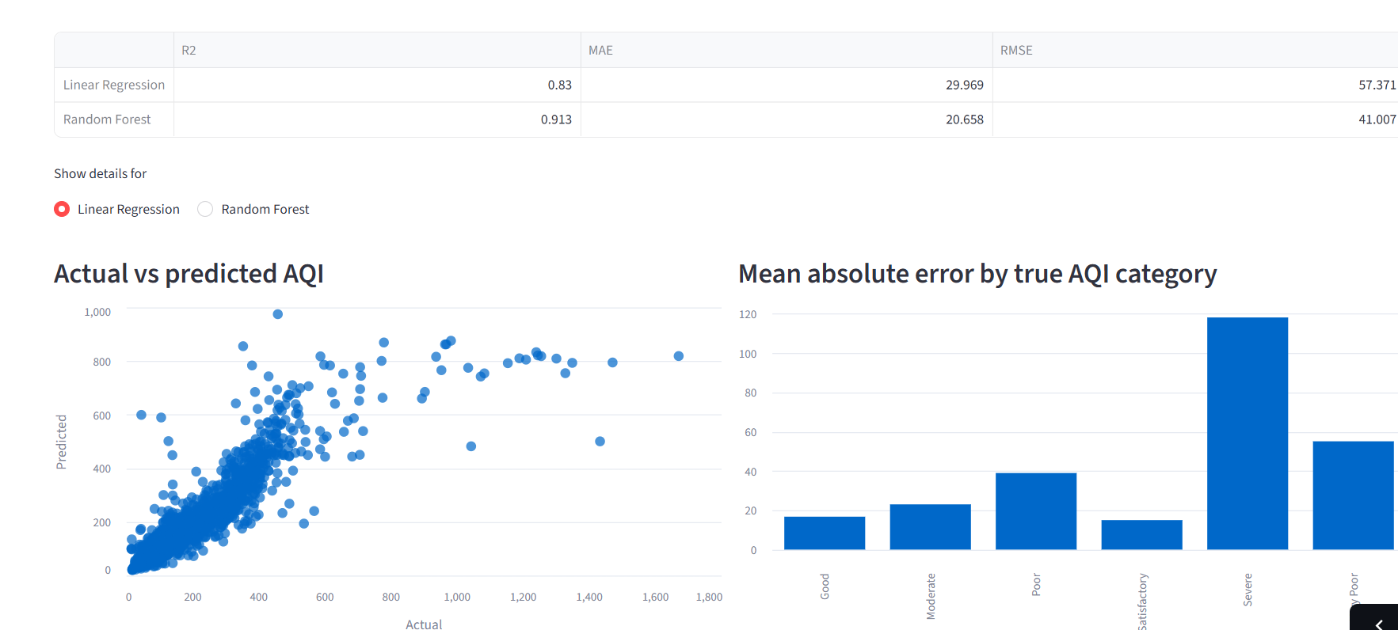
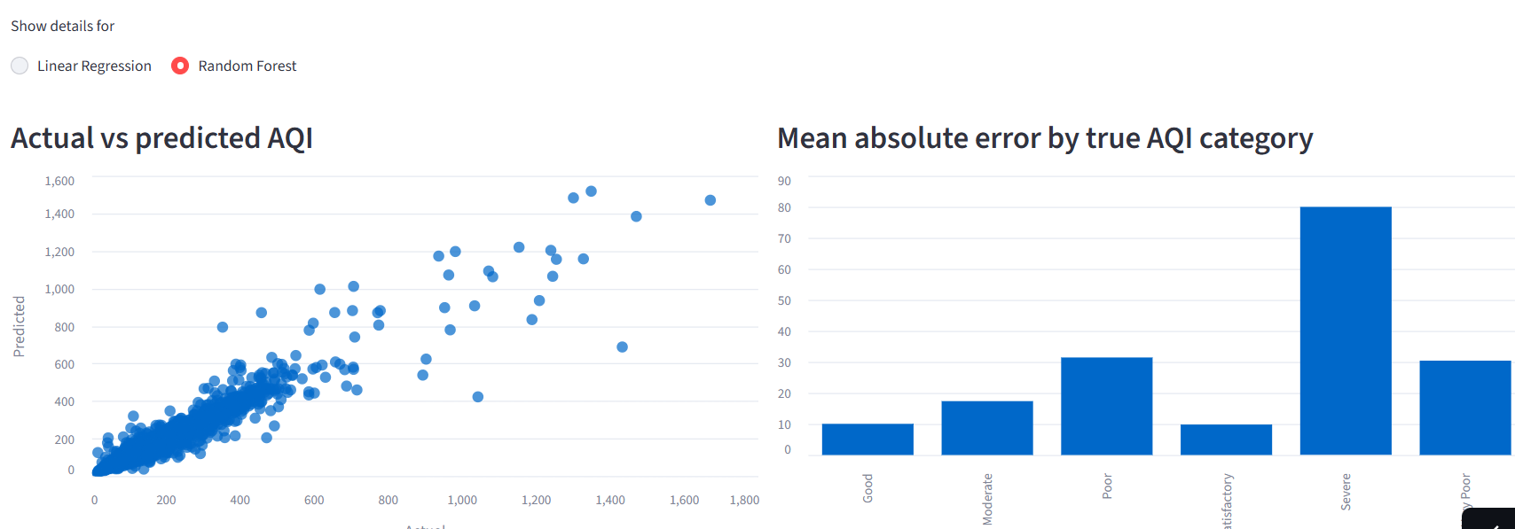
The actual-versus-predicted plot shows that points lie close to the diagonal for low and moderate AQI values, while the spread increases for very high values. This happens because AQI is not perfectly linear in the pollutants: it is computed from piecewise sub-indices and the maximum of them, so a linear model can approximate it well but not exactly. It is also important to note that since AQI is itself calculated from these pollutants, a high R-squared is expected and does not indicate an unrealistic model. The Random Forest improves clearly on the linear model (R-squared 0.913, MAE 20.66, RMSE 41.0) because it can capture the non-linear, maximum-based way in which the AQI is calculated. For the linear model the predictions flatten out at about 800 to 900 even when the actual AQI exceeds 1,000, and the error is largest for the Severe category (about 118 AQI points on average, against about 15 to 20 for Good and Satisfactory); the Random Forest reduces the Severe error to about 80.

7. Classification: Decision Tree (J48) and Naive Bayes

7.1 Concept
Classification predicts a categorical label. Here the target is AQI_Bucket with six classes from Good to Severe. Classification is useful because the public and authorities understand categories such as "Poor" or "Severe" more easily than a raw index number.

7.2 Decision Tree
A decision tree repeatedly splits the data using the pollutant and threshold that gives the greatest information gain, producing a set of if-then rules. The criterion (entropy or gini), the maximum depth and the minimum number of samples per leaf are tuned by a 5-fold grid search on the macro-averaged F1-score; the search selected the entropy criterion (as used by J48 and C4.5), a maximum depth of 10 and at least 4 samples per leaf. Restricting depth and leaf size prevents overfitting, where the tree memorises the training data and performs poorly on new data. Balanced class weights are used so that rare categories such as Good and Severe are not ignored. Decision trees are easy to interpret and do not need feature scaling. The feature importance output shows which pollutants were most useful for splitting.

7.3 Naive Bayes
Naive Bayes applies Bayes' theorem to calculate the probability of each class given the pollutant values, assuming that the features are independent of each other. The Gaussian variant is used because the features are continuous. The algorithm is very fast and works well with small data, but the independence assumption is not true for air pollutants. PM2.5 and PM10, and NO and NO2, are strongly correlated, which can reduce its accuracy.

7.4 Random Forest (benchmark)
A Random Forest builds many decision trees on random subsets of the data and features and combines their votes (classification) or averages their outputs (regression). It captures non-linear relationships and interactions between pollutants and is more robust than a single tree, at the cost of being harder to interpret. In this project it is used as a benchmark: 200 trees are trained for both regression and classification, with balanced class weights for classification.

7.5 Results and Comparison
The three classifiers were trained and tested on the same stratified split (4,970 test days) and are compared in Table 7.1. The decision tree reached an accuracy of 75.21%, clearly ahead of Naive Bayes at 67.26%, which confirms that the independence assumption of Naive Bayes is a handicap for strongly correlated pollutants. The gap is even larger for the macro-averaged F1-score (73.65% against 62.16%), so Naive Bayes copes especially badly with the rarer categories. The Random Forest was the best model with 80.66% accuracy and a macro F1-score of 79.32%, at the cost of being harder to interpret.
Model | Accuracy | Precision | Recall | F1 (weighted) | F1 (macro)
Decision Tree | 75.21% | 76.80% | 75.21% | 75.55% | 73.65%
Naive Bayes | 67.26% | 68.46% | 67.26% | 67.43% | 62.16%
Random Forest | 80.66% | 81.01% | 80.66% | 80.78% | 79.32%
Table 7.1: Classification results on the test set (precision, recall and weighted F1 are weighted averages over the six categories)
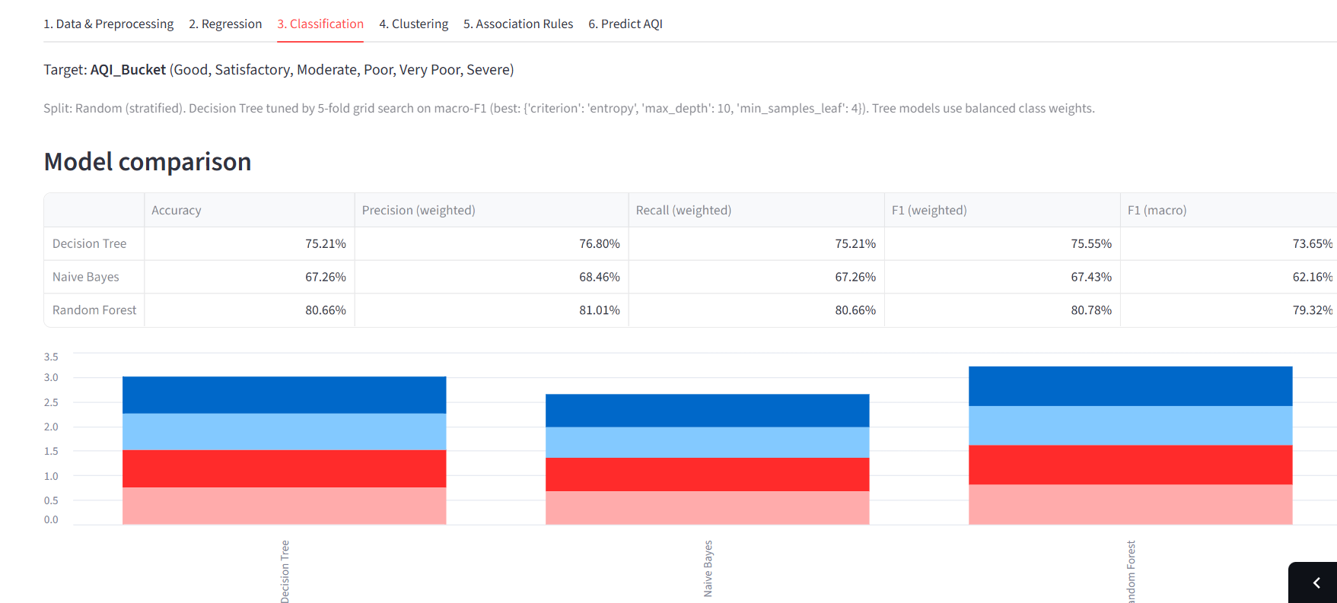
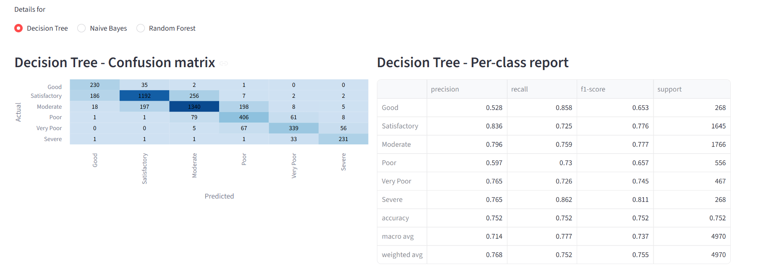
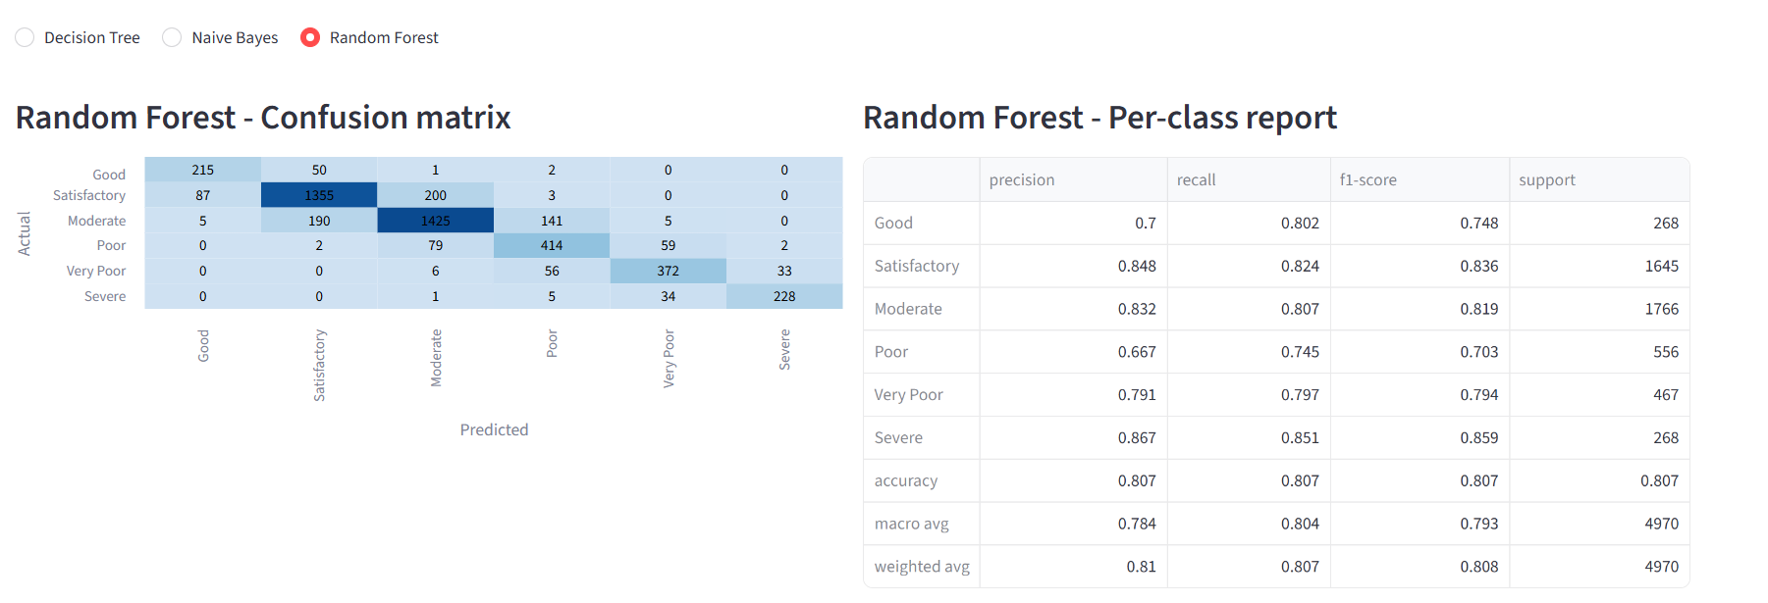
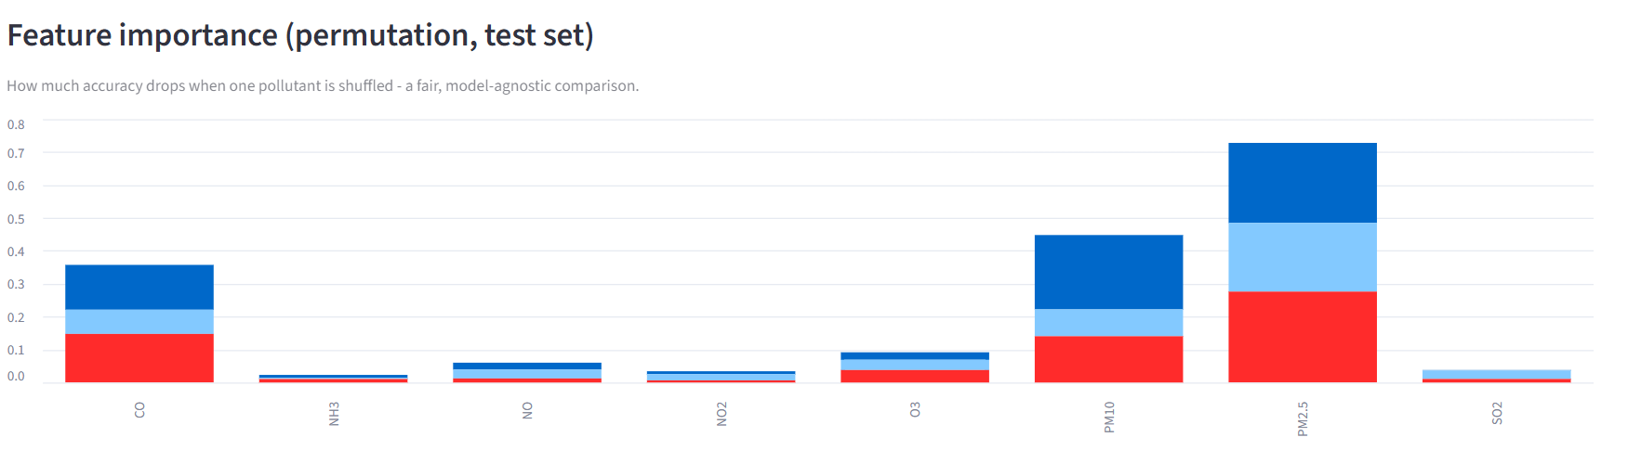

For the decision tree, the per-class F1-scores range from 0.65 to 0.81: Severe (0.81), Moderate (0.78) and Satisfactory (0.78) are predicted best, while Good (0.65) and Poor (0.66) are the hardest. Good has a high recall (0.86) but a low precision (0.53) because 186 of the 1,645 Satisfactory days were labelled Good. The confusion matrices show that most errors occur between neighbouring categories, such as Satisfactory and Moderate (256 Satisfactory days predicted as Moderate) or Moderate and Poor (198 Moderate days predicted as Poor). Errors two or more categories apart are rare, for example only 7 Satisfactory days were predicted as Poor. These errors are less serious than confusing distant categories because the underlying AQI values near a boundary are very close. The permutation importance chart ranks PM2.5 first, followed by PM10 and CO, while the other pollutants contribute little; PM2.5 and CO were also among the strongest predictors in the regression analysis.

8. Clustering Analysis

8.1 Concept
Clustering is an unsupervised technique that groups objects so that objects in the same group are more similar to each other than to those in other groups. No labels are required. Here the objects are cities, described by their average pollutant concentrations over the whole period.

8.2 K-Means Procedure
- The mean of each of the eight pollutants is computed for every city, after capping extreme readings at the 99th percentile.
- The values are standardised using StandardScaler so that pollutants with large numeric ranges do not dominate the distance calculation.
- K-Means is run for k = 2 to 8; the inertia (within-cluster sum of squares) is plotted as the elbow curve and the silhouette score is computed for every k.
- A value of k is chosen using these two curves and the interpretability of the groups. The application proposes the k with the best silhouette score and the user can change k with a slider.

8.3 Results
The elbow curve declines gradually without a sharp bend, and the silhouette score is highest at k = 2 (about 0.3), which only separates a few very polluted cities from the rest. Because this is too coarse to be useful, k = 4 was selected as a compromise that gives groups that are easier to interpret. With only 26 cities, the choice of k also depends on how interpretable the groups are. Table 8.1 gives the mean pollutant level in each cluster.
Cluster | Cities | PM2.5 | PM10 | NO | NO2 | NH3 | CO | SO2 | O3 | Avg AQI
0 | 10 | 33.5 | 58.8 | 8.4 | 15.0 | 19.3 | 0.9 | 7.8 | 28.4 | 84.0
1 | 7 | 52.7 | 117.8 | 27.1 | 15.8 | 14.3 | 1.2 | 18.0 | 21.2 | 136.0
2 | 1 | 67.8 | 109.2 | 22.3 | 55.6 | 17.1 | 18.1 | 51.5 | 39.1 | 452.1
3 | 8 | 83.9 | 136.8 | 20.5 | 35.9 | 23.3 | 1.2 | 12.8 | 42.0 | 183.5
Table 8.1: Cluster profile (mean pollutant levels per cluster; ug/m3, CO in mg/m3)
Cluster 0 (10 cities, mostly southern, coastal and hill-station cities such as Bengaluru, Hyderabad, Chennai, Aizawl and Shillong) is the cleanest group, with the lowest particulate levels and an average AQI of 84. Cluster 3 (8 cities including Delhi, Patna, Gurugram, Lucknow, Kolkata, Jaipur and Bhopal) has the highest particulate pollution, with PM2.5 of about 84 ug/m3 and PM10 of about 137 ug/m3. Cluster 1 (7 cities: Amritsar, Guwahati, Mumbai, Kochi, Talcher, Jorapokhar and Brajrajnagar) lies in between, with high PM10 and relatively high NO. Ahmedabad forms a cluster of its own (cluster 2) because its average CO and SO2 readings are many times higher than in any other city (CO of about 18 mg/m3 against about 1 mg/m3 elsewhere), which gives an average AQI of 452. This may point to sensor or reporting problems in the data and not only to genuine pollution, and it shows how sensitive K-Means is to a single extreme city.
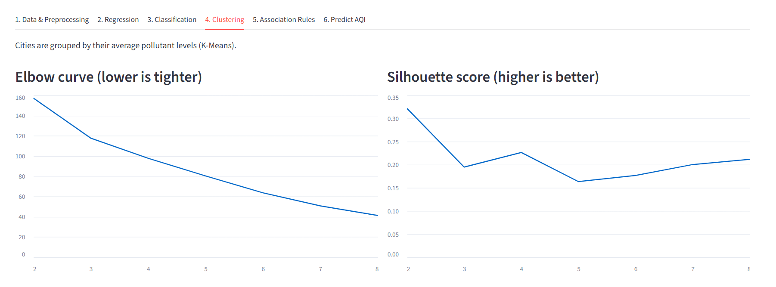
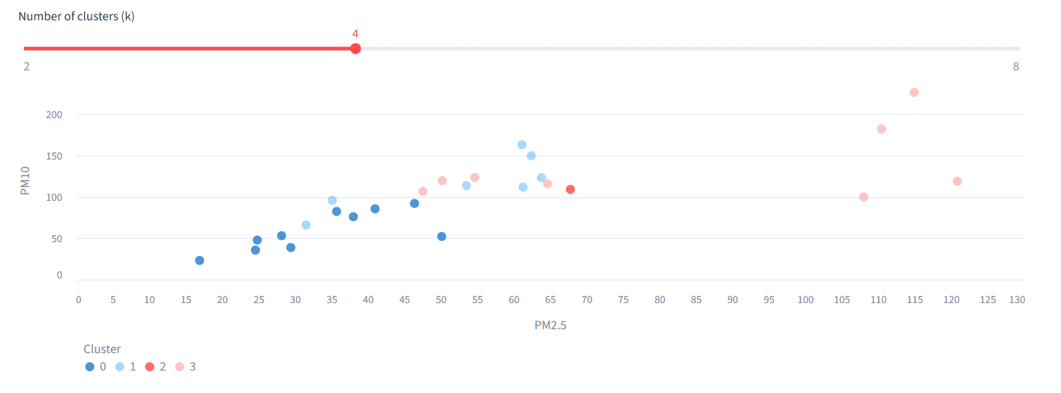
Clustering helps policy-makers plan interventions for groups of cities with similar problems rather than treating every city separately. For example, cities in the highest-pollution cluster may need stricter control of particulate sources, while others may need focus on vehicular emissions.

9. Association Rule Mining

9.1 Concept
Association rule mining discovers items that frequently occur together. A rule has the form IF antecedent THEN consequent. It was originally used for market basket analysis, for example Bread and Butter imply Milk. In this project every day is treated as a "basket" and the "items" are descriptive labels such as PM2.5=High or AQI=Severe.

9.2 Measures
- Support: the fraction of all records that contain both the antecedent and the consequent.
- Confidence: the fraction of records containing the antecedent that also contain the consequent. It measures the reliability of the rule.
- Lift: confidence divided by the expected confidence if the two sides were independent. A lift above 1 shows a real positive association.

9.3 Implementation
Apriori requires categorical data, so each of the six pollutants (PM2.5, PM10, NO2, CO, SO2 and O3) is discretised into three equal-frequency bins labelled Low, Medium and High using quantiles. The AQI_Bucket is added as an item. A random sample of up to 8,000 records is used to keep the computation fast. The data is converted to a one-hot (true/false) table, frequent itemsets are found with the user-selected minimum support, and rules are generated with the selected minimum confidence. An option lets the user show only rules whose consequent is an AQI category, and a minimum-lift setting removes rules that are no better than chance.

9.4 Results
With a minimum support of 0.15, a minimum confidence of 0.65 and the filter that keeps only rules predicting an AQI level, three rules were found (Table 9.1). All three link low particulate levels to the Satisfactory category. For example, days on which both PM10 and PM2.5 are in the Low group are Satisfactory with a confidence of 70.4% and a lift of 2.11, which means that this combination makes a Satisfactory day about twice as likely as on an average day. Because the AQI is calculated mainly from PM2.5 and PM10, such rules are expected; the value of the technique here is that it expresses the relationships in an easily readable if-then form without requiring a target variable. Rules for the worse categories do not appear at this support level because Poor, Very Poor and Severe each cover less than 15% of the days; lowering the minimum support reveals them.
IF | THEN | Support | Confidence | Lift
PM10=Low, PM2.5=Low | AQI=Satisfactory | 0.169 | 0.704 | 2.11
PM10=Low | AQI=Satisfactory | 0.219 | 0.657 | 1.97
PM2.5=Low | AQI=Satisfactory | 0.219 | 0.656 | 1.97
Table 9.1: Association rules found with support 0.15 and confidence 0.65
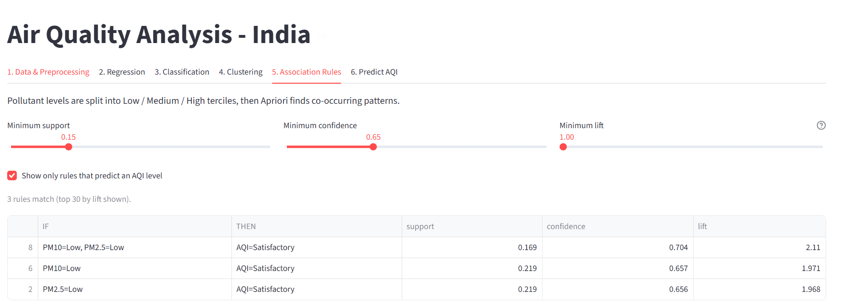

10. Streamlit Application
The application (app.py) combines all stages in one interface. The cleaned data and trained models are cached so that the application responds quickly when the user changes parameters. The interface has six tabs, described in Table 10.1.
Tab | Function | User interaction
1. Data & Preprocessing | Shows row counts, missing values, AQI category distribution, average AQI by city, monthly trend and correlation heatmap | City selection box
2. Regression | Compares Linear Regression and Random Forest (R2, MAE, RMSE) with coefficients, actual vs predicted plot and error by category | Model selection
3. Classification | Compares Decision Tree, Naive Bayes and Random Forest (accuracy, precision, recall, F1) with confusion matrices, per-class reports and feature importance | Model selection
4. Clustering | Shows elbow curve, silhouette score, cluster plot and cluster profile | Slider for k
5. Association Rules | Generates and lists rules with support, confidence and lift | Support, confidence and lift sliders, AQI-only filter
6. Predict AQI | Predicts AQI (two regression models) and AQI category (three classifiers, with confidence) from entered pollutant values | Number inputs and Predict button
Table 10.1: Tabs of the application
The prediction tab turns the analysis into a usable tool. The user enters the eight pollutant values (defaults are the dataset medians), and the application returns the AQI from the two regression models and the category predicted by the three classifiers together with the confidence of each. In the example shown below (PM2.5 of 100 ug/m3, PM10 of about 100 ug/m3 and CO of 2 mg/m3, with the other pollutants at typical values) Linear Regression predicts an AQI of 198 (Moderate) and the Random Forest 214 (Poor). The Decision Tree and Random Forest predict Poor (85% and 68% confidence) while Naive Bayes predicts Moderate (89%); the case lies close to the Moderate/Poor boundary at an AQI of 200, so the models disagree. A reference scale of AQI ranges is shown below the result.
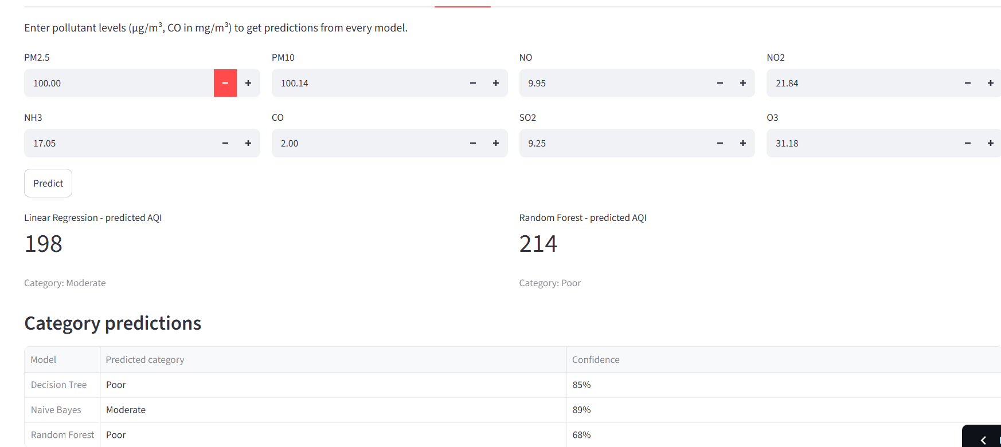
The application is run from the terminal using the command `streamlit run app.py` with city_day.csv placed in the same folder; the dataset can alternatively be uploaded from the sidebar, where the train/test split (random or chronological) can also be chosen.

11. Results and Discussion
Discussion. The regression and classification results show that the pollutant concentrations are strong predictors of AQI, which is expected because the index is calculated from them. The more useful findings are therefore the relative importance of the pollutants and the comparison of the models. PM2.5 and CO have the largest regression coefficients, and PM2.5, PM10 and CO are the most important features for classification. Among the classifiers, the decision tree (75.2% accuracy) clearly outperformed Naive Bayes (67.3%), as expected because the pollutants are correlated and the tree does not assume independence, and the Random Forest was best (80.7%). The same ordering appears for regression, where the Random Forest (R-squared 0.913, MAE 20.7) beats the linear model (0.830, MAE 30.0), which shows that the non-linear, maximum-based definition of the AQI is better captured by tree-based models. No model reaches near-perfect accuracy even though the AQI is computed from the pollutants. One reason is that many pollutant readings had to be imputed (PM10 and NH3 are missing on more than a third of the days), so the inputs do not always match what was used to compute the index; another is that the categories change at fixed AQI boundaries, so days near a boundary are easily confused.
Clustering and association rules provide a different type of knowledge. Clustering shows which cities behave similarly and could be handled with common policies, while the rules show which combinations of pollutant levels co-occur with severe air quality. Together with the seasonal trend charts, these results give a more complete picture than any single technique.
The project also showed the importance of preprocessing. The choice of city-wise median imputation and percentile capping directly affects the model inputs, and without them the missing values would have either removed a large part of the dataset or distorted the models.

12. Conclusion
This mini project successfully applied the main data mining techniques learned in the course to a large real-world air quality dataset. Preprocessing made the data suitable for modelling; linear regression predicted the AQI value and revealed the influence of each pollutant; the decision tree and Naive Bayes classified the AQI category and were compared; K-Means grouped cities by pollution profile; and Apriori produced readable rules linking pollutant levels with air quality categories. A Random Forest benchmark gave the best results (R-squared 0.913 for regression and 80.7% accuracy for classification), showing that non-linear models suit the way the AQI is calculated.

13. Limitations and Future Scope

13.1 Limitations
- The data ends in mid-2020 and has many missing values for some pollutants and cities.
- Since AQI is derived from the pollutants, the prediction task is partly deterministic and the high accuracy should be interpreted with care. Even so, accuracy is limited to 75% to 81% because many pollutant values had to be imputed.
- A random split lets the models see days that are adjacent in time to the test days. When the application is switched to a chronological split (training on earlier days and testing on the latest 20%, from early December 2019 to July 2020), the Random Forest still reaches an R-squared of about 0.91, but its MAE falls to about 16.7 AQI points because the test period, which includes the COVID-19 lockdown, had lower AQI values. MAE in AQI points is therefore not directly comparable between the two splits.
- Linear regression cannot capture the piecewise, maximum-based nature of the AQI calculation exactly.
- Only 26 cities are available, which limits the clustering analysis.
- Weather factors such as temperature, humidity and wind speed are not included.

13.2 Future Scope
- Add meteorological data and try further non-linear models such as Gradient Boosting, in addition to the Random Forest already used as a benchmark.
- Perform time-series forecasting to predict the AQI of the coming days.
- Use the station-level files for finer analysis inside a city.
- Deploy the application online and connect it to live CPCB data for real-time alerts.

